

**CMPE 275: Enterprise Application Development**

**Project 1– MOOC**

**Submitted By:**

**Santhosh Kumar Neerumalla (008822840)**

**Theja Vangumalli (008983832)**

**Gaurav Gampa (009293739)**

**Rajagopalan Venkataramanan (008983806)**

**Birva Joshi (009287577)**

Table of Contents

Abstract 3

Introduction 3

System Requirements 4

Analyzing Requirements 4

Workflow Scenarios 4

Architecture 6

System Implementation 7

Modules 7

Description of Packages 8

Sequence Diagrams 9

Testing of the System 14

Test Data 20

Hurdles and Blockades 21

Limitations 21

Future Scope 21

Knowledge gained during Development 21

References 21

# Abstract

Massive Open Online Course (MOOC) is an online course to provide unlimited access to learning content via web. The project is a modern server side infrastructure that provides API’s to gain access via sign-in and sign-up, list all courses, list courses by ID and host competitions. The load is distributed across all servers through techniques like job bidding and this reduces the delay due to excess traffic. The system is built on asynchronous netty framework which simplifies the use of TCP socket servers. The netty framework helps to integrate with Google’s protobuf for machine to machine communication. The use of Google’s protocol buffers makes it possible for any client-server technology developed using protobuf to make use of the API’s.

# Introduction

The emergence of cloud technologies has led to the increase in storage of large amounts of data over the network. The data is stored on the network at many places and retrieved upon request with the help of neighbors connected to the data store. Different vendors developed different systems like Amazon S3, Cloud Store and HDFS for cloud storage and retrieval.

This application is designed to gain access to the learning content over the web. The nodes of the network are unknown and network is established dynamically allowing different nodes to leave and join the network. The system’s goal is to deliver the content to client or other nodes robustly at all times. The following are the features of the current system:

1. Allows a new user to Sign-up.
2. Provides security using Sign-in.
3. Lists all the courses.
4. List courses by their ID.
5. Host Competitions.

The current application has been developed using the following technologies –

1. **Netty:** A non-blocking I/O (NIO) framework for developing client server applications in java. Netty includes the implementation of reactor pattern in programming, which is used to serve multiple requests delivered concurrently.
2. **Google Protocol Buffers:** Communication between programs over the wire is made possible by the use of protocol buffers. Google’s protocol buffers are platform independent, language independent and extensible mechanisms to serialize structured data. They are similar to XML but are simpler, quicker and smaller.
3. **MongoDB:** Mongo DB is a free, open source and document -oriented database for storing structured and non-structured data. Its similarity with table – based relational database and support of JSON-like documents makes its integration with other applications easier.

# System Requirements

## Analyzing Requirements

The system can be deemed successful, if it satisfies the following requirements:

1. Allows registration using Sign-up.

2. Allows access to content via Sign-in.

3. Retrieves a list of courses.

4. Retrieve a course by ID.

5. Host Competitions.

## Workflow Scenarios

1. **Sign Up:**

A client sends a sign-up request to the server to make use the MOOC services. A client has to sign-up in order to perform anyone of the operations listed above. The client enters his details and if the user already exists, he is prompted with an error message “User Already Exists”. If the user does not exist his details are stored into the database. The user gets “SUCCESS” message on successful sign-up. The request is pushed to the server using a channel and the client receives the response back from the channel.

1. **Sign In:**

A client sends a sign-in request to view his account details. If the user is not already registered he is prompted by an error message “username and password did not match”. The user gets “SUCCESS” message on successful sign-in. A client has to sign-in before he can request other operations.

1. **List Courses:**

The client sends a list courses request to the server in order to retrieve all the courses available as learning content. A repeated message field is used in the protocol buffer’s message format which can be used any number of times. The order of the values of the retrieved message is preserved by repeated field. The user is displayed a list of all courses with their ID’s. These ID’s can be used to get a detailed description of each course.

1. **List Course by ID**

A user can get the completed details of a course by using this option. The user sends the request to the server and the server sends back the course details associated to the course ID specified by the client. If the specified ID does not exist the client is prompted with an error message.

**5. Host Competition**

A client sends a host competition request to a cluster. The leader of the cluster forwards the request to all the clusters. Each node of every cluster votes whether to take up the job or not. The cumulative of all votes serves as an indicator for accepting or rejecting the request. The first cluster that replies back to the client and is delegated the job to host the competition.

# Architecture

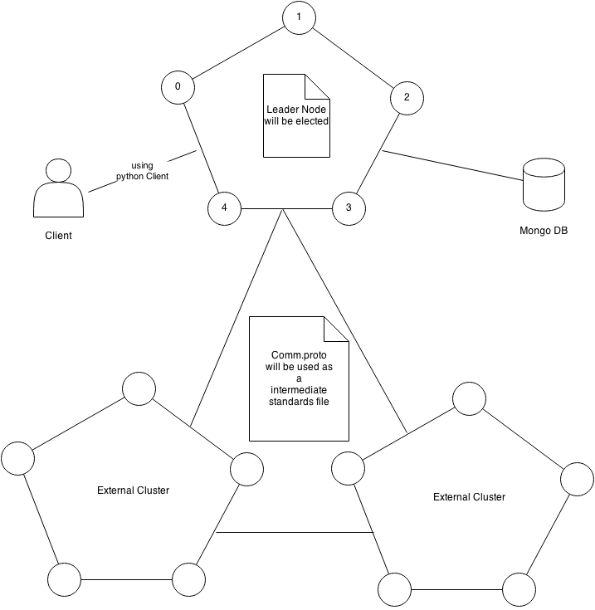

# System Implementation

## Modules

**Leader Election:**

In an overlay network, leader election is the process of designating a single node in a cluster as the leader which is the sole instance for communication with client or other clusters. As soon as the nodes try to establish connection, leader election is initiated by all the nodes. The project is built on uni-directional ring topology and makes use of Le Lann Chang and Roberts (LCR) algorithm to elect a leader for the cluster. The use of LCR algorithm reduces the number of interactions between different servers and improves the processing speed of the leader election process.

**Job Bidding:**

Job Bidding is done within the cluster. Job Bidding is the process of checking which server is most suitable to serve a request received from the client. When a client requests, a job proposal is sent to the leader of the particular cluster. The leader forms a Job Bid request and sends it to all the servers by adding its weight. The weight in the Job Bid object is nothing but the total of all the weights of each job served. This request is forwarded to all the servers. Each server checks its weight with the weight of the previous server. If the weight of current server is less than that of the previous server the “node to” field of Job Bid is replaced with the current node IP and forwarded to next node. The process is stopped when the leader receives back the Job Bid object. The job is processed by whichever nodes IP is present in the Job Bid object’s “node to” field.

**Voting:**

Voting is done between different clusters. Voting in this project is initiated when a client requests the cluster to host a competition. When a server receives a request from client, it sends a “FindLeader” request to all the clusters. The cluster that initiated the request receives the IP addresses of the leaders of all clusters, which it stores. Then an “InitVoting” request is send to the leaders of all the clusters. Then the cluster either agrees or disagrees to host competition. The first cluster which responds back sends a message back to the user saying that it hosts the competition.

## Description of Packages

The following is the package structure of the source code:

* **poke.monitor:** The client side responses from the server are handled by this package.
* **poke.resources:** Implements the jobs requested by the client like sign-in, sign-up, list courses, list course by ID and host competitions.
* **poke.server:** Responsible for starting all the managers (Election Manager, Heartbeat Manager etc.,) and monitor and establish and monitoring connections between servers.
* **poke.server.conf:** Stores the routing information of all nodes for clusters internal use.
* **poke.server.management:** This package is responsible to keep track of server behavior or server status.
* **poke.server.queue:** This package has various queues like PerChannelQueue to process requests and response.
* **poke.server.resources:** Provides the abstraction which allows the server to handle requests.

## Sequence Diagrams

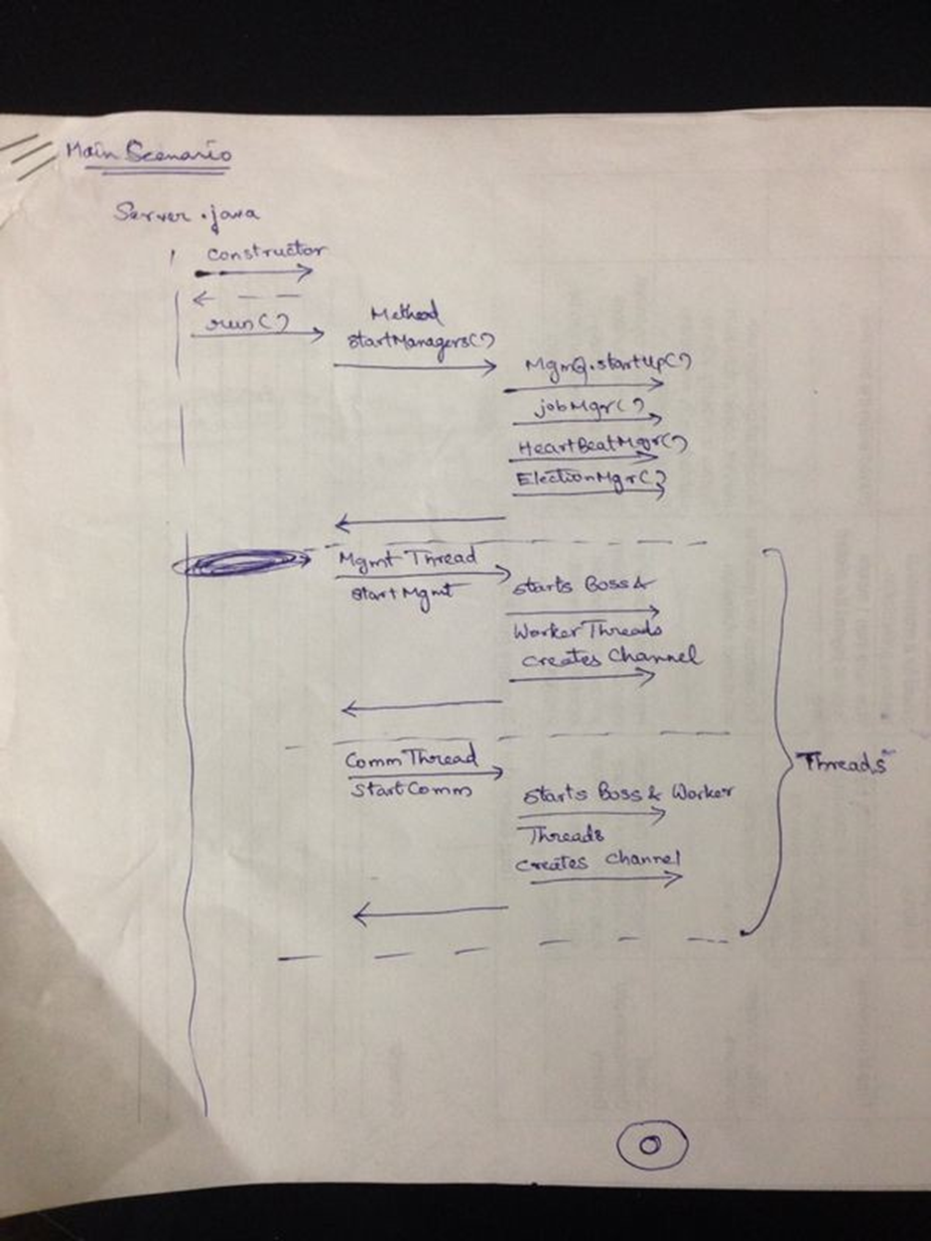

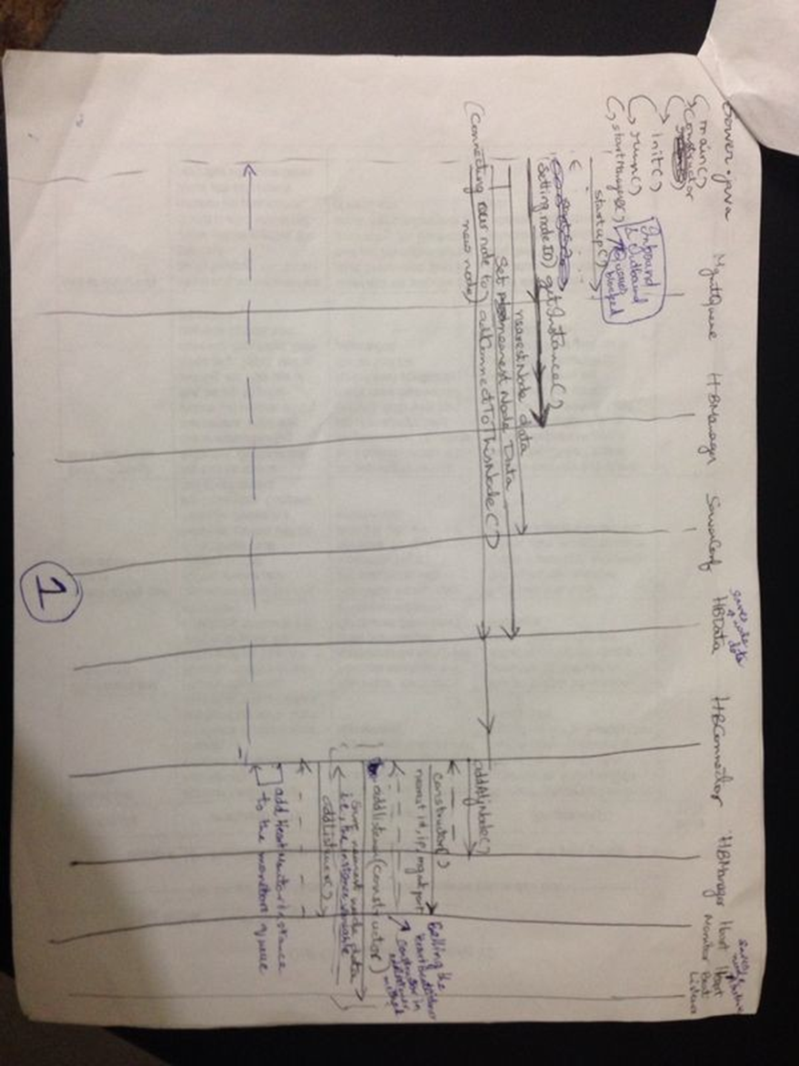

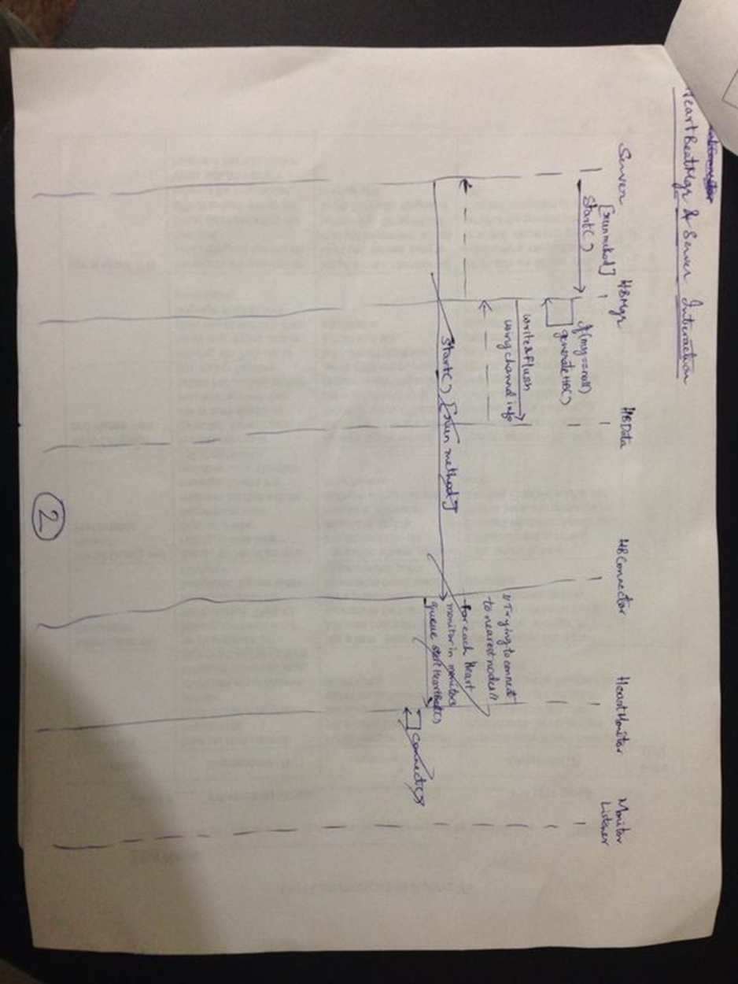

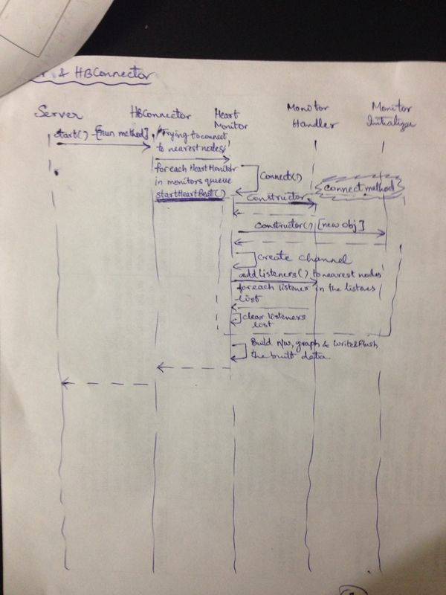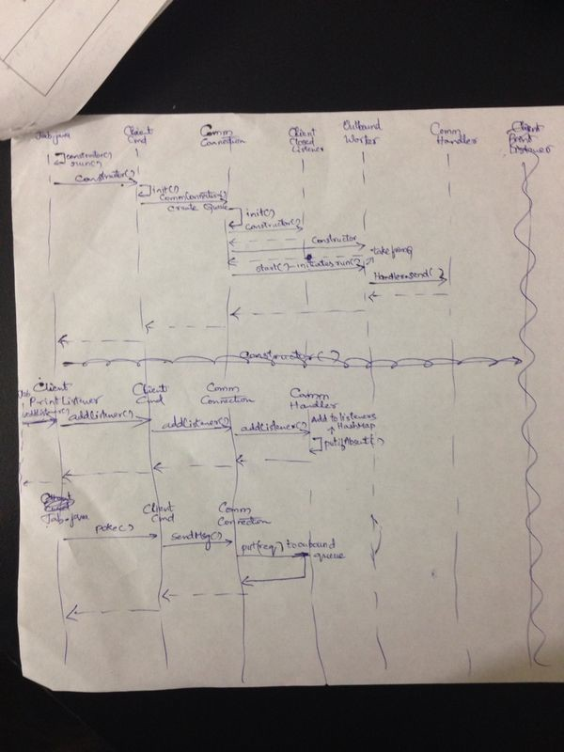

## Testing of the System

1. Heart Beats:

As soon as the system is up, each server (node) sends heartbeat among themselves to check the connections between them. The below screenshot depicts the same:

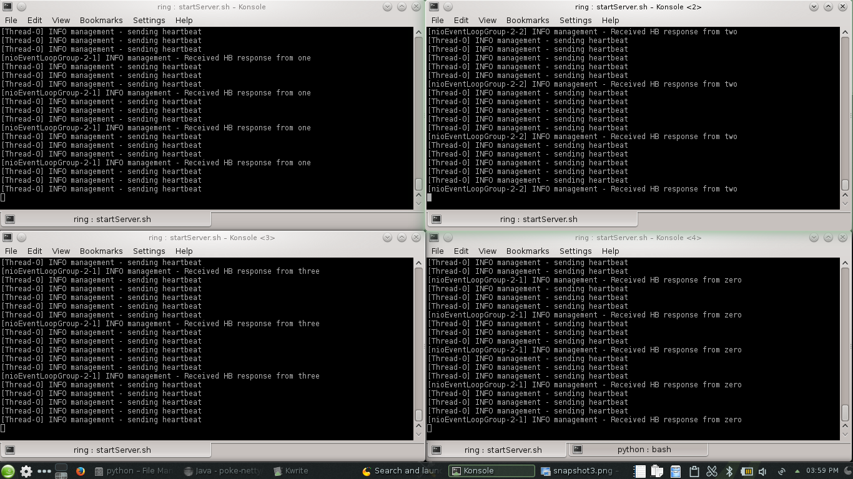

1. Leader Election:

When the nodes are up, leader election is initiated and one of them is nominated as the leader.

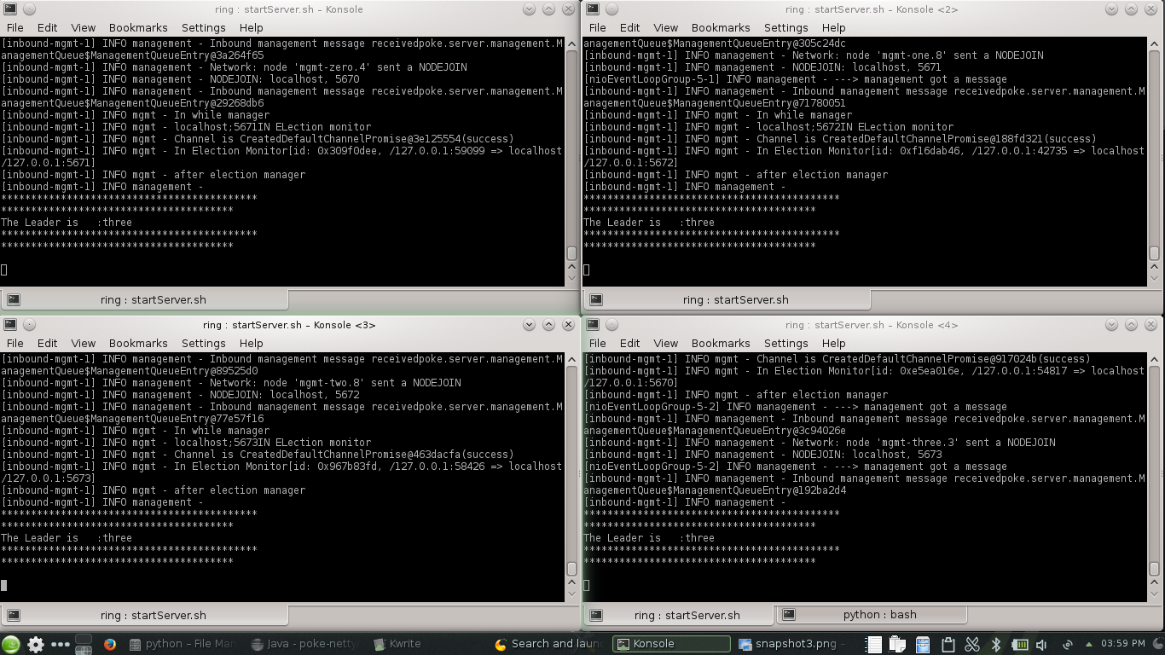

1. Sign In

When a client makes a sign in request, the user is prompted to enter his username and password. The details entered are checked with the already existing details and the client is logged in to the system.

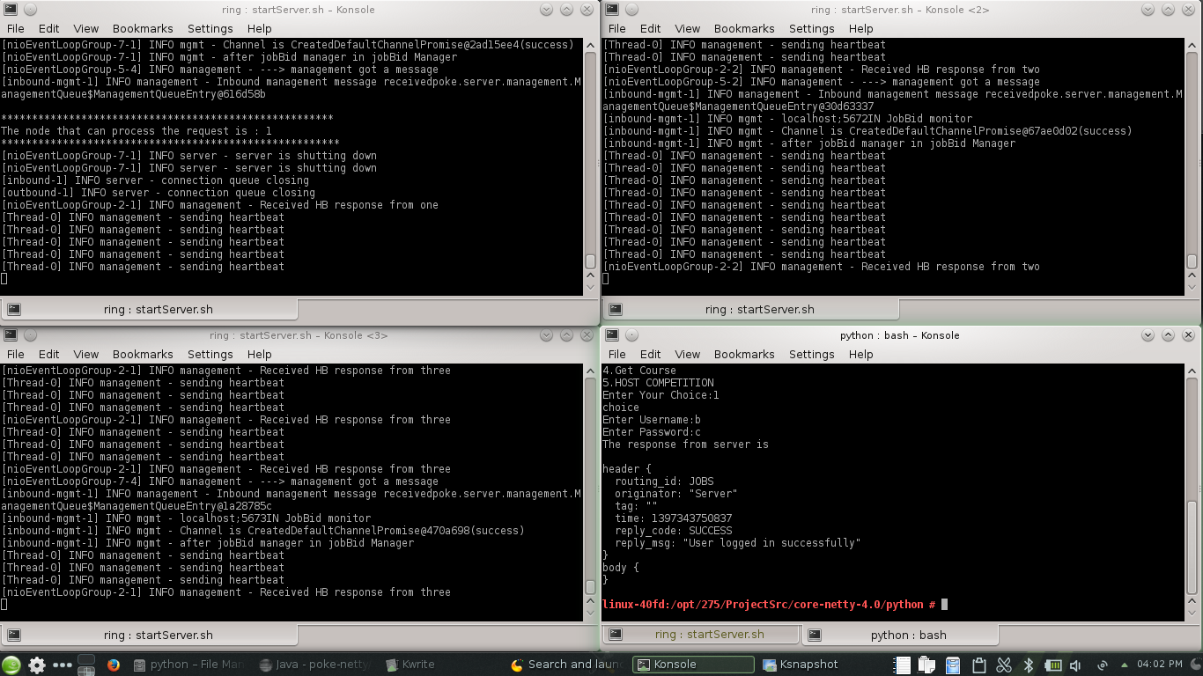

1. Sign Up

A new user can register his account with by giving full name, username and password as input which are persisted into database. The details are later verified while sign in process.

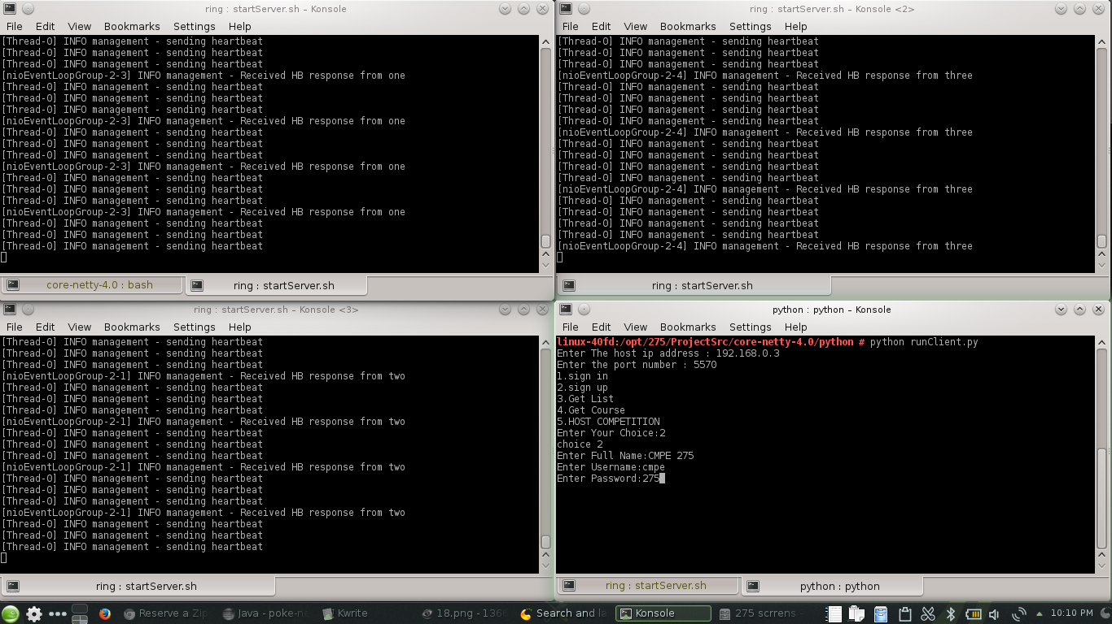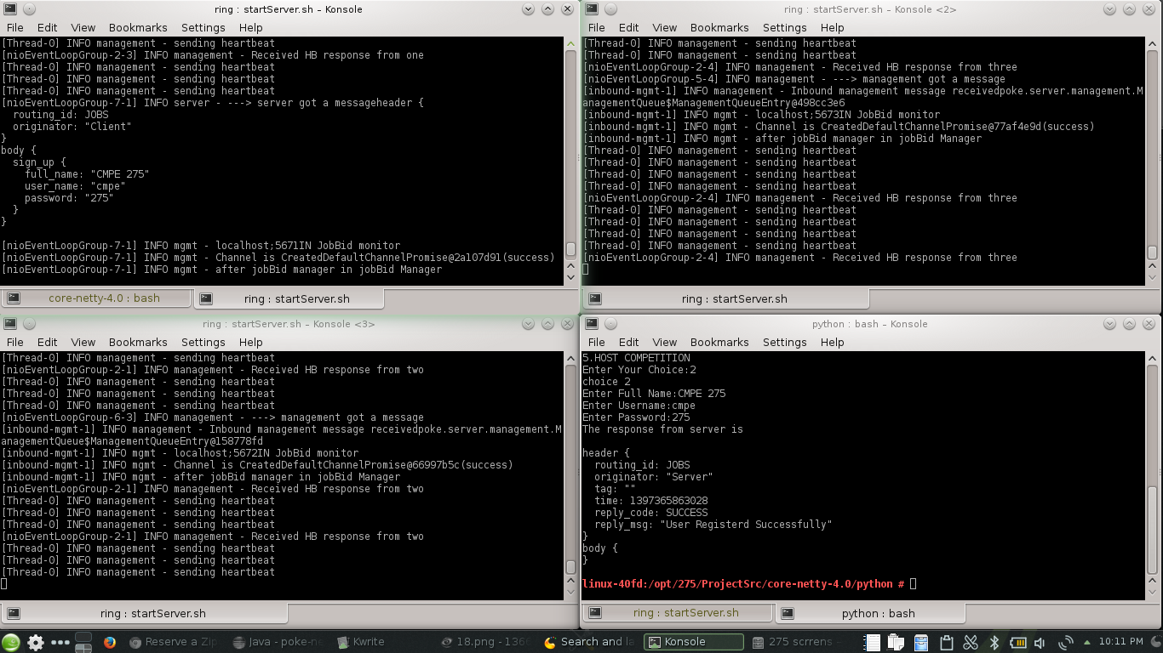

1. List Courses

A client can request to display the list of all courses existing in the system. The course id and course name are given as output which are later used for requesting a particular course description.

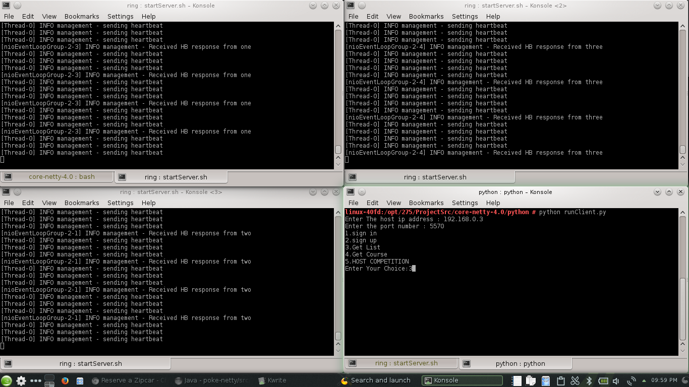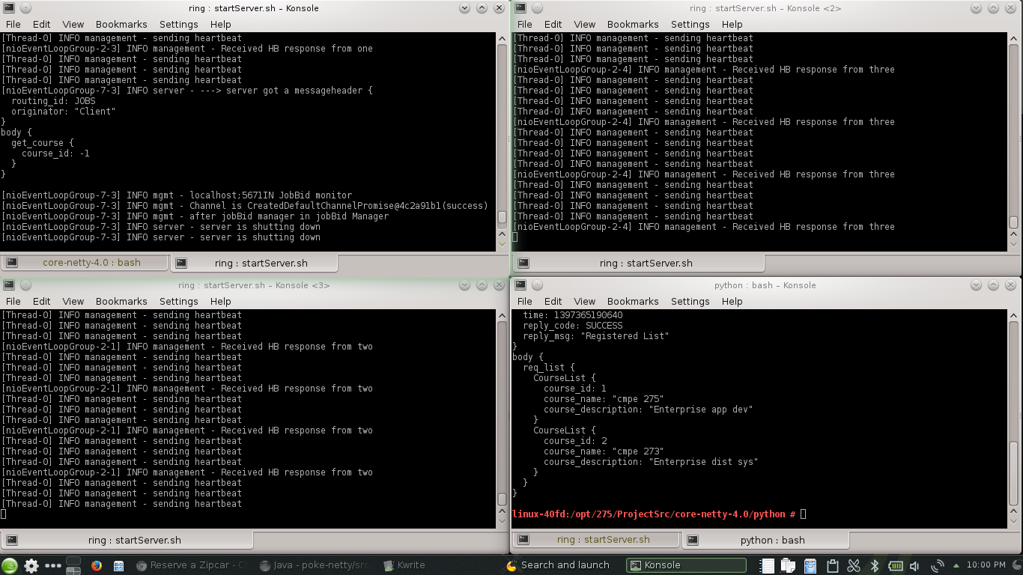

1. Get Course Info

A client can get the full description of a course by using the course id from list all courses request.

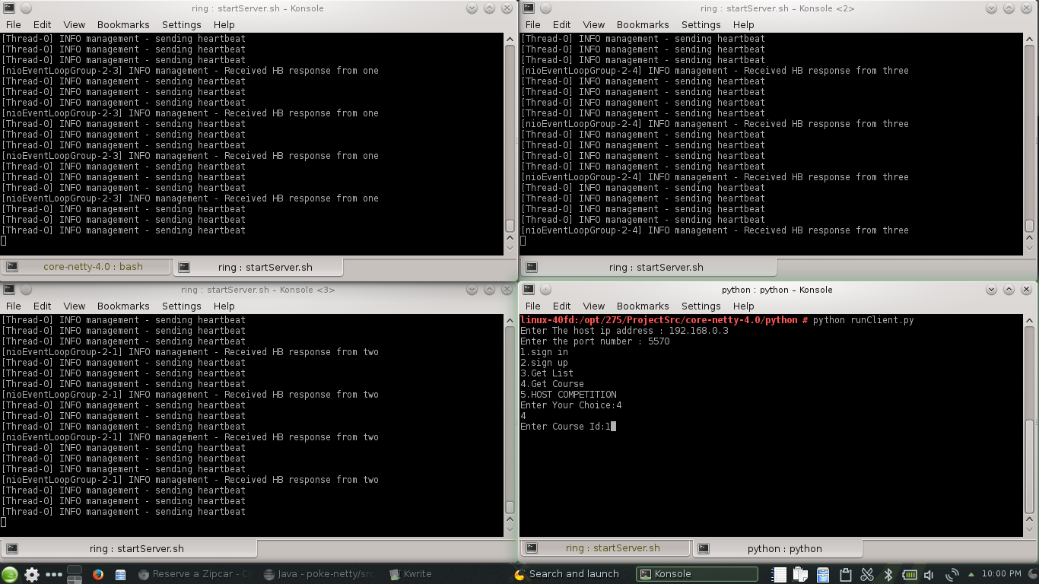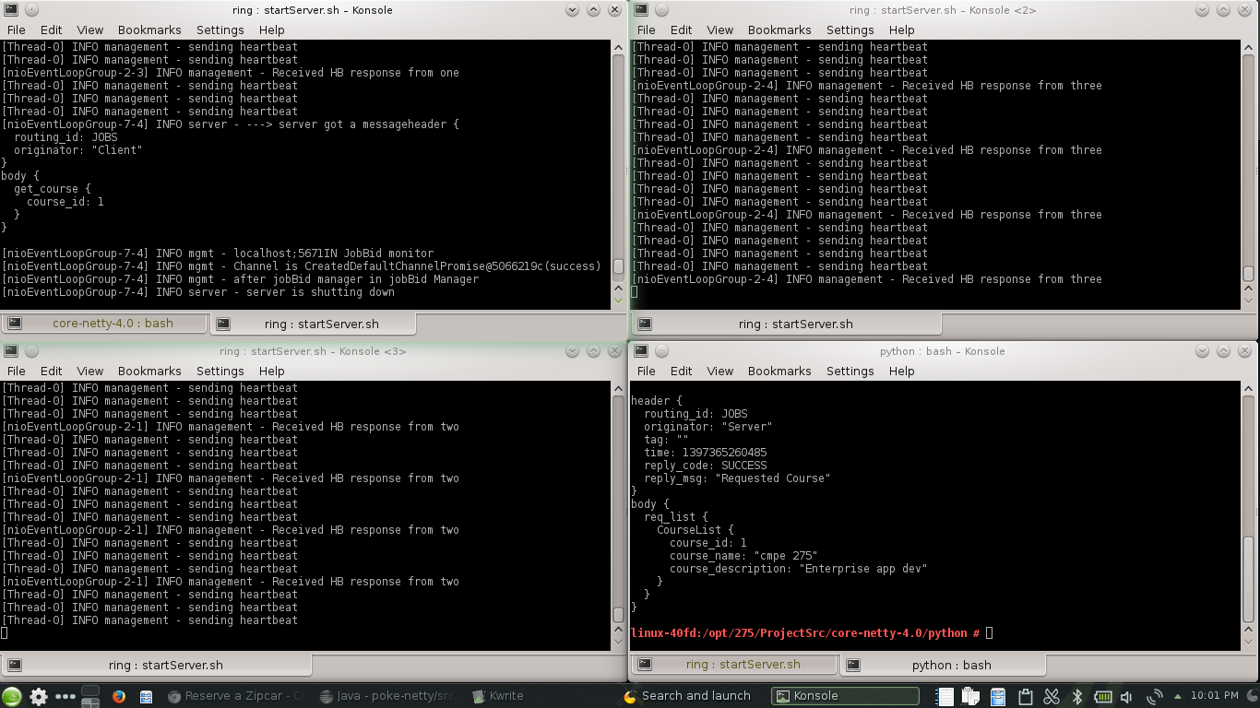

1. Job Bidding

Once a client makes a request for any of the jobs (sign in, sign up, get list, get course or host competition), job bidding is done to check who serves the job request.

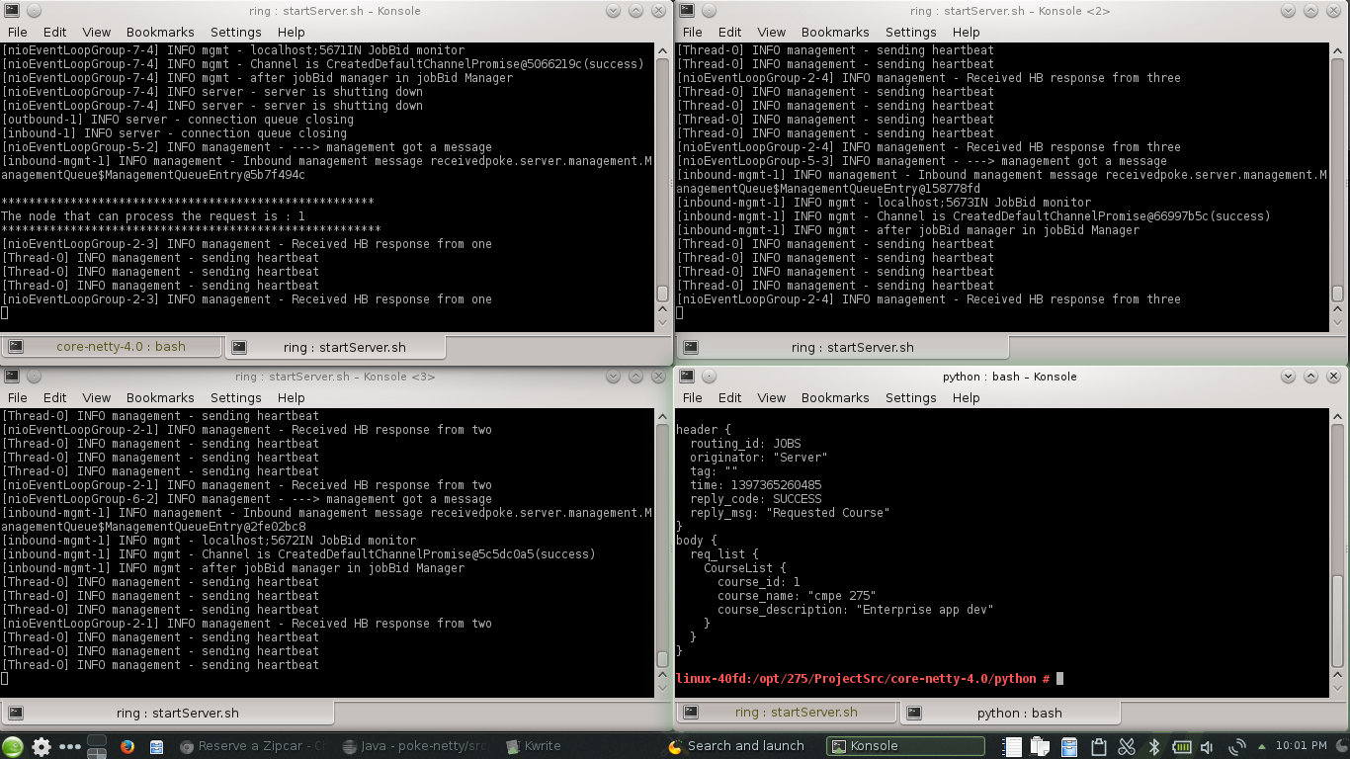

1. Voting

When a client sends a host competition request to a cluster, each cluster votes on the job whether to vote a competition or not. The request is processed by the first cluster which votes a request.

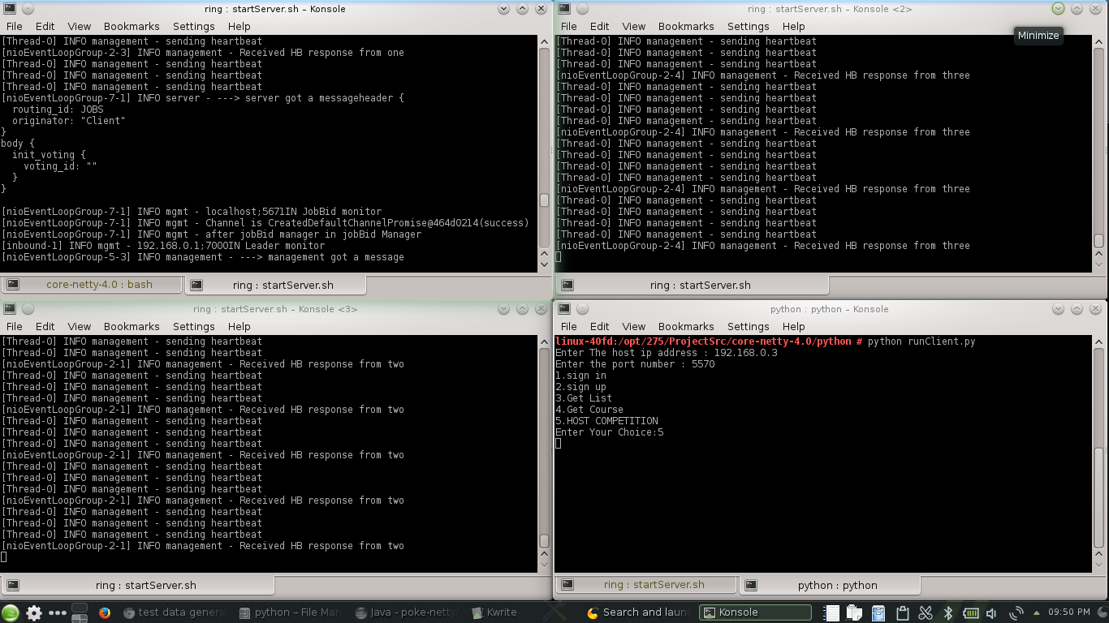

# Test Data

List of courses in the database

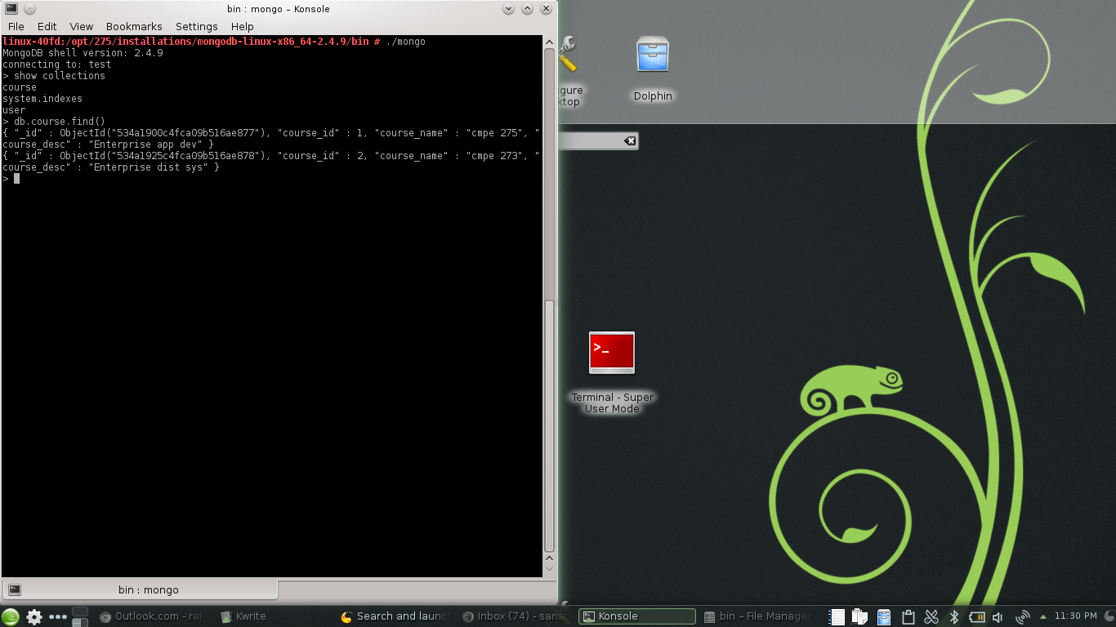

User Data

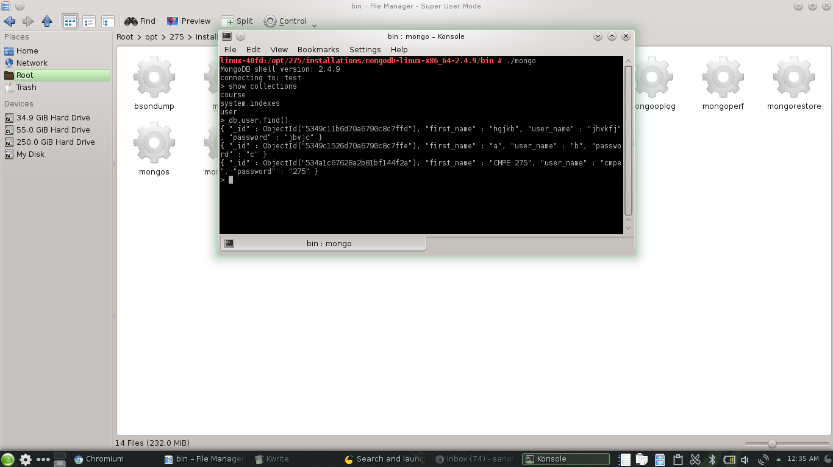

# Hurdles and Blockades

* Firewall issues while integration of various operating systems. (Arch Linux, Ubuntu, Windows, Bodhi Linux and OpenSuse)
* Cross communication between various programming languages like python and java.
* When trying to send a request form the java client we were arriving at an error asking to set graph.node_id, beat.node_id and beat.time_ref. So, we solved the problem by using a python client which was an alternative.

# Limitations

* The system provides only basic functionalities. The user cannot add or remove a course.
* The system makes use of uni-directional ring topology. So, when data is transmitted from one node to another it has to pass through all nodes. Increase in the number of nodes in the network increases the latency of data transmission.

# Future Scope

* The features like adding, updating or deleting a namespace, adding, updating or deleting a job can be done.
* The existing ring topology can be replaced or modified to avoid transmission delays.
* Replicating data across each server to avoid single point of failure.

# Knowledge gained during Development

* The working of an overlay network and the procedure to handle node failures.
* Working with this project helps us to learn how to use netty framework to implement asynchronous programming.
* The project made us learn the importance of using a common protocol for client-server and server-server communications across the network.

# References

1. <http://en.wikipedia.org/>
2. <https://developers.google.com/protocol-buffers/>
3. <http://www.buzzle.com/articles/advantages-and-disadvantages-of-different-network-topologies.html>
4. <http://netty.io/>